**DAILY ONLINE ACTIVITIES SUMMARY**

|  |  |  |  |  |  |  |  |  |
| --- | --- | --- | --- | --- | --- | --- | --- | --- |
| **Date:** | **21/05/2020** | | | | | **Name:** | **Syed Hudaif Ibrahim** | |
| **Sem & Sec** | **6th /B** | | | | | **USN:** | **4AL17CS104** | |
| **Online Test Summary** | | | | | | | | |
| **Subject** | | **OS IA Test** | | | | | | |
| **Max. Marks** | | **30** | | **Score** | | | **30** | |
| **Certification Course Summary** | | | | | | | | |
| **Course** | **Full Stack Web Developer** | | | | | | | |
| **Certificate Provider** | | | **Udemy** | | **Duration** | | | **4 weeks** |
| **Coding Challenges** | | | | | | | | |
| **Problem Statement:**  **1.** Write a menu program in Python to find Area-Circle, Circumference-Circle, Area- Square, Circumference-Square using functions with menu choice Create separate functions for each choice of menu  **2.** Python program to print right angled triangle | | | | | | | | |
| **Status: Completed** | | | | | | | | |
| **Uploaded the report in GitHub** | | | | | **Yes** | | | |
| **If yes Repository name** | | | | | <https://github.com/SyedHudaif/Online-Coding-updates>  <https://github.com/SyedHudaif/Certification-course-updates> | | | |
| **Uploaded the report in slack** | | | | | **Yes** | | | |

**Online Test Details**

OS TEST Details:

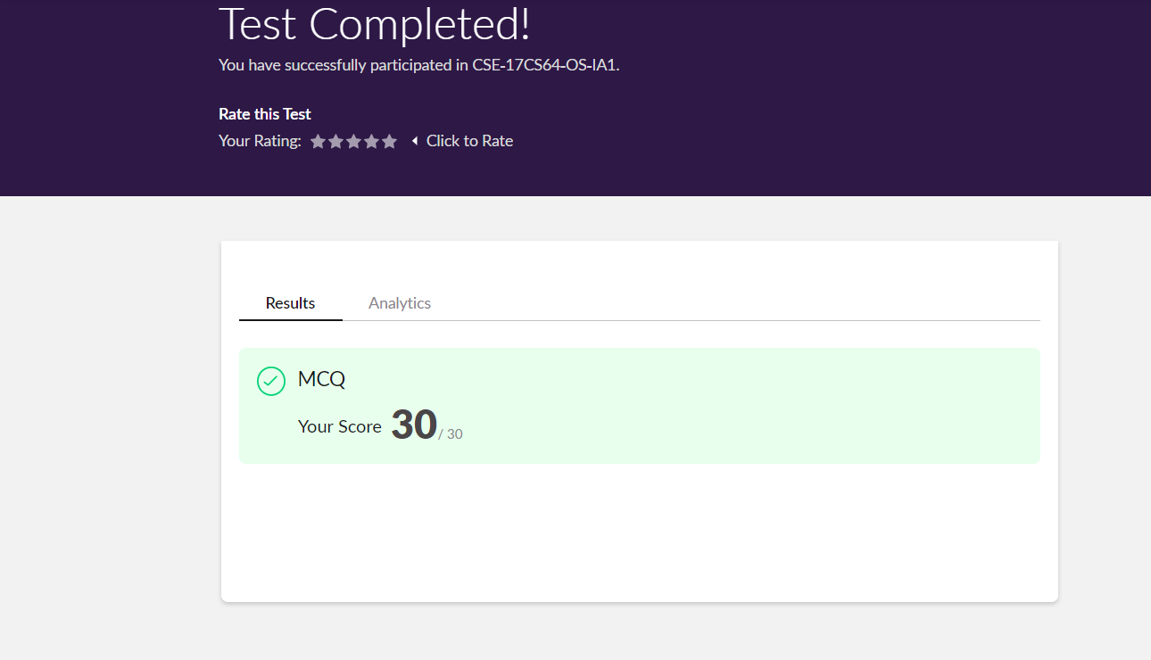

**Online Certification Details**

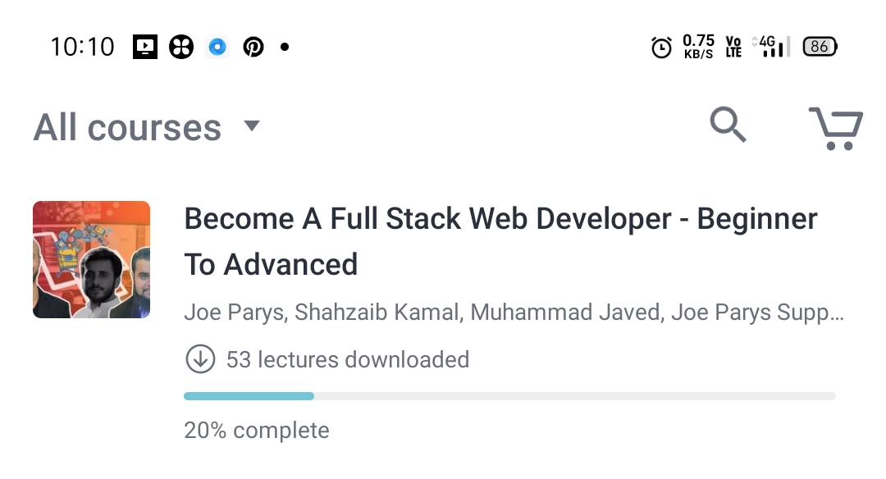

**Coding Challenge Details**

1. Write a menu program in Python to find Area-Circle, Circumference-Circle, Area- Square, Circumference-Square using functions with menu choice  
   Create separate functions for each choice of menu

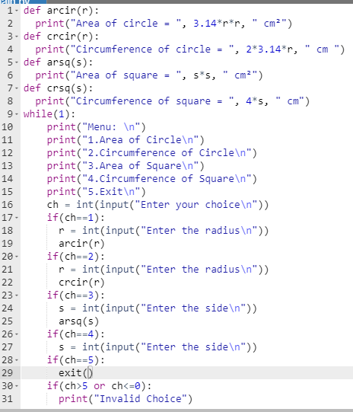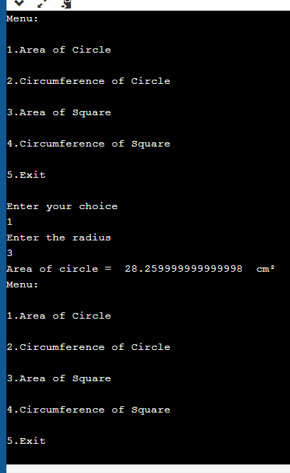

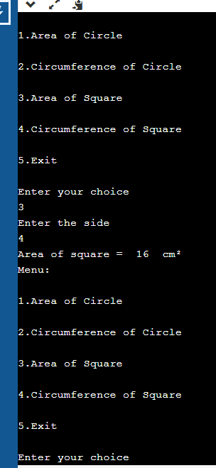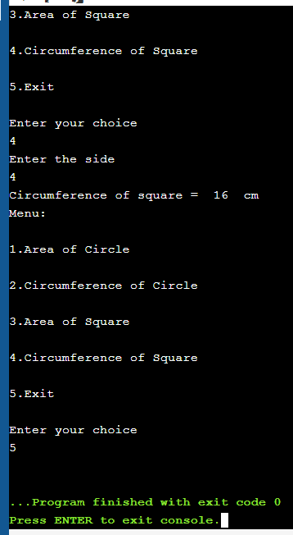

1. Python program to print right angled triangle.

